Ruediger Pre-K Supply List for 2020-2021
In efforts of keeping our materials clean and individual due to COVID-19 we ask your help to provide the items below.

2 Playdough
4 Glue sticks
Crayons (24 count)
Markers (8 count)
1 Hard shell 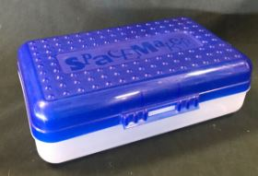 pencil case
1 box gallon size Ziploc-type bags
Large backpack
1”Kindermat
Snacks to share with class
1 Change of Clothes (Shirt, shorts, and underwear)
1 Field Trip T-shirt ($12.00)
Sign Up for FOCUS Parent Portal @leonschools.net

